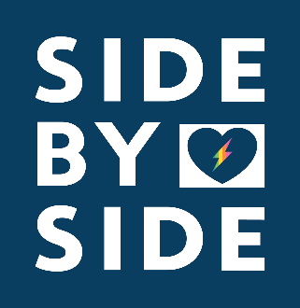
NEWS from
Side by Side

Alison Gips
(540) 613-1996
Agips613@sidebyside.org

FOR IMMEDIATE RELEASE
September 14th, 2017

SIDE BY SIDE WANTS YOU TO SING YOUR HEART OUT

HARRISONBURG, Va— If you love to sing and support your local LGBTQ+ youth community, start warming up your voice. On November 14, 2017, Side by Side is hosting Sing Your Heart Out, a karaoke benefit contest that allows members of the Harrisonburg community to sing in a safe and welcoming space, while supporting a worthy cause. The benefit contest will take place in the taproom at Brothers Craft Brewing in Harrisonburg, Va. To enter, there’s a five-dollar donation, which perspective contestants can make on the Side by Side website. Doors will open at 5p.m. and audience members will receive a tour of the Brothers Craft Brewing taproom before the competition begins.
After each contestant performs, a panel of 5 judges will deliberate and determine a first, second and third place winner. First place will walk away with a free keg of Brothers Craft Brewing Beer and a sense of pride for supporting his or her local LGBTQ+ youth community. “Side by Side is all about fostering a safe space that allows youth to explore, engage and celebrate who they are,” Emma Yacksoo, Side by Side director of youth programs and services, said. “This is precisely what Sing Your Heart Out aims to do.”

###

